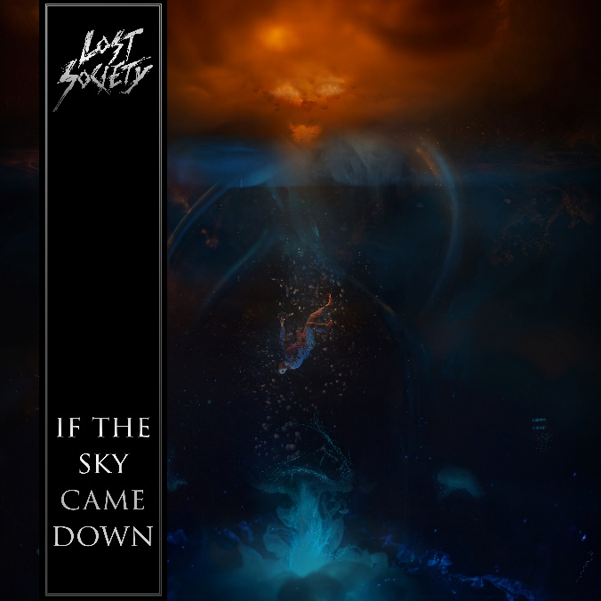

LOST SOCIETY

»If The Sky Came Down«

OUT: September 30th 2022
Line up: | LOST SOCIETY online:
Samy Elbanna | Vocals, Guitar  Arttu Lesonen | Guitar  Mirko Lehtinen | Bass  Taz Fagerström | Drums | facebook.com/lostsocietyfinland/  instagram.com/lostsocietyfi/  twitter.com/LostSocietyFI  lostsocietyfinland.com
Pounding riffs weighing several tons? Check! Catchy choruses and symphonic flashes? Check! Relentless eruptions of utterly chaotic, yet catchy modern metal? Check! Passionate performances by elaborate musicians? Check!
You got it right: over the last twelve adrenaline-filled years, braindead™ Finnish cannonball squad LOST SOCIETY has been fearlessly exploring the lights and shadows of the world of heavy metal. Still, despite the dirty deeds of the past years and the praise of legendary colleagues such as Kreator's Mille Petrozza and Sepultura's Andreas Kisser, it now feels like the band's rocket is just about to take off.
Enter 2022. The epochs of darkness have just been left behind...
"Our new full-length recording If The Sky Came Down would not have become like this had it not been for the unfortunate events of the past two years", nods guitarist-vocalist Samy Elbanna, who formed LOST SOCIETY in 2010.
"We have indeed put together a year and a half of mental turbulence and a daunting tragedy for one album..."
Samy, who is a modest Finn, must be corrected a bit: for one hell of an album! In other words this is not a vague opinion but a cold fact: LOST SOCIETY – featuring guitarist Arttu Lesonen, bassist Mirko Lehtinen and drummer Taz Fagerström as well – is about to unleash the most ambitious, versatile and innovative record of their career. Well, so far.
"We wanted to expand the band's musical horizon without abandoning the vicious roots of our energetic sound. The result? Well, according to my very non-objective view, If The Sky Came Down turned out to be a giant step forward from previous albums, and we've now found the heart and soul of LOST SOCIETY. Period!"
"Believe me: we did not leave any stone unturned while crafting and sharpening If The Sky Came Down. Every time there was a tentative new song on the table, we challenged ourselves all over again to make it shinier, more inventive and whatnot. And only after an extremely intense writing and arranging period, we started meticulous pre-production which didn't end until we felt there's all in for the jackpot!"
If The Sky Came Down is a bona fide example of what may happen when utterly talented musicians recognize the magnificent feeling: we are capable of reaching the heavy metal skies.
"The song 112 was the musical beginning of everything for this record. It sets the exploding tone perfectly, and therefore it is also the first single track from the record. But as always, 112 is only able to give a small hint of what’s in store for the whole album", smiles Elbanna.
"If I rush to some of the extremes of the record, let's grab the banger (We Are The) Braindead first. Mercy is neither sought nor given: this is just a supremely energetic outburst with a big chorus – and among all this, it’s also a deep bow to the band's past!"
"Elsewhere we storm to the industrial melancholy and sick samples of Hurt Me and to the dark and elegant riffing and huge-sounding symphonic ambitiousness of Awake. And these are just some selected spices to whet your appetite..."
The definitive nail in the coffin is the record's spectacular closer Suffocating. There are cold shivers down the listener's spine as Samy Elbanna spits fragile but powerful lines such as "only death can heal me" and "the air is pure but I'm suffocating".
"Suffocating is very intense and stripped song with a serious vibe of endless despair. During the vocal recording, there was pretty much just unbroken silence between takes... Even if I say it, the end result hits nerves that I never thought were even possible!"
The lyrics may sometimes be secondary in the mystical realms of rock 'n' roll, but If The Sky Came Down heads out to another highway – and certainly not just within the unique serenity of aforementioned Suffocating.
"This album is "a goodbye note" and some kind of a Downward Spiral of mine", Elbanna declares.
"The lyrics are by far the most personal so far. I set out on this gloomy path with the song Creature, which I ended up writing at a hazy time when everything was beginning to fall apart in my life. I did not restrict or censor myself in any way, and the record became an extremely honest outburst of these dark feelings when everything has been lost and nothing matters anymore."
Immortalized at famous Finnvox (Nightwish, HIM, Children Of Bodom) and iStudio – both in Helsinki, Finland – under the firm command of a producer, recording engineer and the album's co-writer Joonas Parkkonen, If The Sky Came Down sounds massive and modern, yet organic and stripped-down as well.
"Our fertile co-operation with Joonas started with the previous album No Absolution (2020). During the common road so far, we have found an incredible chemistry when it comes to songwriting, mixing and producing. Joonas truly understands what LOST SOCIETY is aiming for and is purely the most inspiring person around... If The Sky Came Down, which is once again brought to the hungry heavy metal masses by the renowned Nuclear Blast Records, is a testament to this all!"
And now the rockets are about to be launched again... What does the future look like?
"Guess what? We will tour and tour some more... Don't worry: when LOST SOCIETY gets started, we’re not stopping anytime soon", laughs Elbanna.

